# Office AMS: Search IMPORT/EXPORT

|  |  |
| --- | --- |
| Summary: | Applies to: |
| This sample demonstrates how to import and export search settings for a SharePoint Online site using the search CSOM in a console application. | * Office 365 Multi-Tenant (MT) |
| Solution: | Core.SearchSettingsPortability, version 1.0 |
| Author: | Brian Michely (Microsoft) |
| //*********************************************************  // THIS CODE IS PROVIDED *AS IS* WITHOUT WARRANTY OF  // ANY KIND, EITHER EXPRESS OR IMPLIED, INCLUDING ANY  // IMPLIED WARRANTIES OF FITNESS FOR A PARTICULAR  // PURPOSE, MERCHANTABILITY, OR NON-INFRINGEMENT.  //********************************************************* | |

## Version log

Change log between different releases.

|  |  |
| --- | --- |
| Version | Notes |
| 1.0 | Initial   * Export Search Settings * Import Search Settings |

# General comments

“Search Portability” supports transferring the following items:

* + Results sources
  + Query rules
  + Result types
  + Schema
  + Custom ranking models

You can transfer settings between a tenant, site collections or sites. This can be done via the SharePoint UI or the SharePoint search CSOM. This sample demonstrates how to transfer settings using the CSOM. It is a simple console application that prompts for the following arguments:

* Type of operation to perform (Import | Export)
* Path for settings file (where to save for export, or where to import from)
* URL of SharePoint Online site
* User name (ex: [yourname@yourtenant.microsoftonline.com](mailto:yourname@yourtenant.microsoftonline.com))
* Password

The code will attempt to authenticate via the [SharePointOnlineCredentials](http://msdn.microsoft.com/en-us/library/office/microsoft.sharepoint.client.sharepointonlinecredentials(v=office.15).aspx) object which provides credentials to access SharePoint Online resources

context.Credentials = new SharePointOnlineCredentials(userName, password);

context.Load(context.Web, w => w.Title);

context.ExecuteQuery();

Once authenticated, the app will use CSOM to either Import or Export by calling the appropriate method. The methods use the [**SearchConfigurationPortability**](http://msdn.microsoft.com/en-us/library/office/microsoft.sharepoint.client.search.portability.searchconfigurationportability(v=office.15).aspx) and [**SeachObjectOwner**](http://msdn.microsoft.com/en-us/library/office/microsoft.office.server.search.administration.searchobjectowner(v=office.15).aspx) objects and the code executes either the **ExportSearchSettings** method or **ImportSearchSettings** method to perform the action requested by the user in the console.

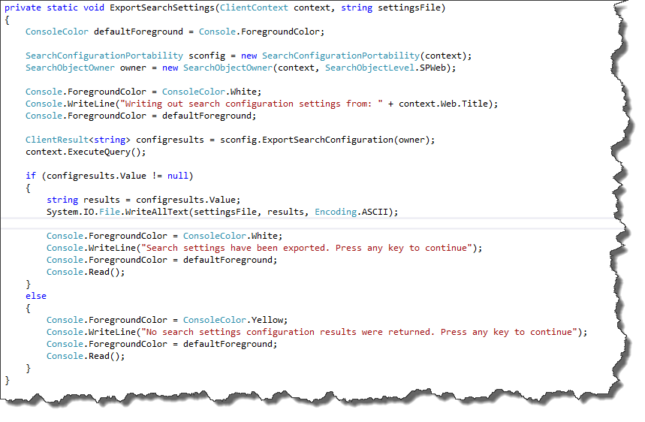

Example of the Export method

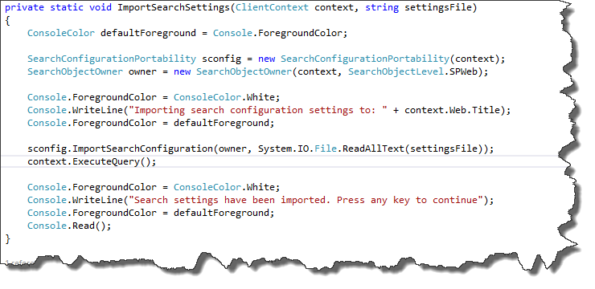

Example of the Import method

The end result from an export is a search settings .xml file that can be use elsewhere by performing the import shown above.

# Dependencies

•Microsoft.SharePoint.Client.dll

•Microsoft.SharePoint.Client.Runtime.dll

•Microsoft.Office.Server.Search.Administration.dll

•Microsoft.SharePoint.Client.Search.Portability.dll